**Weekly Status Update for Week 7**

**Timeline:** From 17-04-2024 to 24-04-2024

**What we have done:**

**Code:**

* Institution account login then can click into the institution dashboard page #199 Linxi
* Click "manage request" button in institution dashboard to jump into modal2 page #200 Bohong
* Add institution service/controller and so on springboot part in backend Andy done
* Enable backend to return request information classified by institution Songxuan done

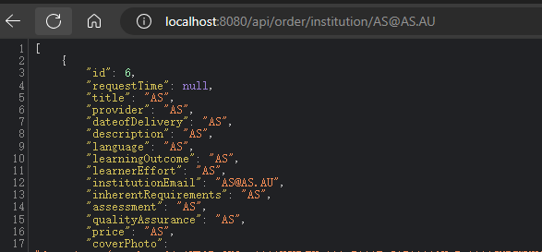

* Configue email information of backend Nuoxi done

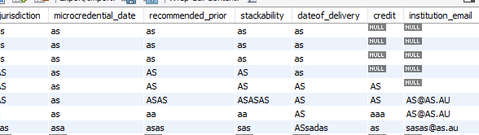

**Documentation**: done

Mitchell

* All client meeting minutes and tutorial meeting minutes have been migrated to GitHub (issues are closed on GitHub),
* A risk log has also been made and outlines some of the main risks with the project (although issue is still in progress).
* A revised elevator pitch has been drafted, pending review by client and tutor
* I've done some research into GitHub workflows to see if any are viable for CI/CD for our project
* WP3 research is on the way, but is only in the early stages.

What we will do next week

**Code:**  
Complete the back-end implementation for edit metadata function Songxuan and Nuoxi

Complete the institution service/controllers and so on in backend Andy

Complete the institution dashboard page include all functions and buttons (edit, detail, pass. Reject) Bohong, Linxi

**Documentation**: